Tytuł atykułu/Title of the article
(Times New Roman, 16pkt., Bold, wyśrodkowany/centered)
Imię i nazwisko (Times New Roman, 12 pkt. bold, wyśrodkowany/centered)
Afiliacja/affiliation (Times New Roman, 12 pkt.)
ORCID: 0000-0000-0000-0000, e-mail: aaaa@bbbb.com (Times New Roman, 10 pkt.)
Streszczenie/Abstract (Times New Roman, 10 pkt.): (od 200-400 wyrazów/ 200-400 words)

Keywords:

JEL:

Introduction
Theoretical premises
As underlined by P. Kotler and H. Barich, image is the sum of beliefs, attitudes and impressions that a person or a group of people has in relation to a given object [Cohen 1963, pp. 48-63, Kotler, Barich 1991, Cornelissen 2000, Dąbrowski, 2010, pp. 65-67]. On the other hand, W.J. Crissy highlights its diversity, due to the variety of human values, experiences, knowledge and needs. It is essential that an entity may shape it by means of various instruments (including marketing ones). According to S.H. Britt, once an image is shaped, it more strongly affects people’s behaviour than the sum of its elements [Crissy 1971; Britt 1985]. Times New Roman 12 pkt., normalny/normal; 1pkt. odstępu/interline)
Methodology
Results
Summary, recommendations

Table 1. Tyłył tablei/Title of the table (Times New Roman, 11 pkt., wyśrodkowane/centered)

Source: own study, based on ....

Fig. 1. Tytuł wykresu/Title of the figure

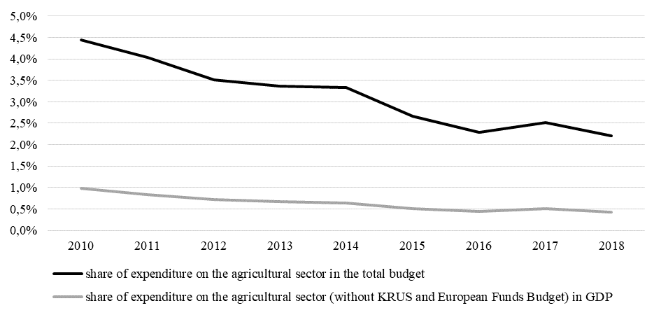

Source: own study, based on (http://www...............).

(1) | $$z_{ij}=\frac{x_{ij}-\min_{i}\left\{x_{ij}\right\}}{\max_{i}\left\{x_{ij}\right\}-\min_{i}\left\{x_{ij}\right\}}$$
whereas in the case of inhibitors (X₁, X₃, X₄, X₅, X₆, X₁₅, X₁₈) it is based on the formula:
(2) | $$z_{ij}=\frac{\max_{i}\left\{x_{ij}\right\}-x_{ij}}{\max_{i}\left\{x_{ij}\right\}-\min_{i}\left\{x_{ij}\right\}}$$

Przypisy/Foot notes (Przypisy bibliograficzne w systemie harvardzkim polegają na powoływaniu się na dane źródło bezpośrednio w tekście pracy, (a nie u dołu strony jak w tradycyjnych systemach) bez podawania jego pełnego opisu bibliograficznego. W kwadratowym nawiasie umieszczamy nazwisko autora, na którego się powołujemy oraz datę wydania danej książki, czy artykułu.)
Bibliographic footnotes in the Harvard rely on referring to the data source directly in the text, (rather than at the bottom as in traditional systems) without specifying a complete reference. The square brackets put the author's name, in which is claimed and the date of issue of the book or article.)
Przykład/Example:
As underlined by P. Kotler and H. Barich, image is the sum of beliefs, attitudes and impressions that a person or a group of people has in relation to a given object [Cohen 1963, pp. 48-63, Kotler, Barich 1991, Cornelissen 2000, Dąbrowski, 2010, pp. 65-67]. On the other hand, W.J. Crissy highlights its diversity, due to the variety of human values, experiences, knowledge and needs. It is essential that an entity may shape it by means of various instruments (including marketing ones). According to S.H. Britt, once an image is shaped, it more strongly affects people’s behaviour than the sum of its elements [Crissy 1971; Britt 1985].

References

BASU, S., TAYLOR, A., (1999). Business Cycles in International Historical Perspective, Journal of Economic Perspectives, No 13.

